Add/Update Preferred Name
For Students:
(Only your first (given) name can be changed/updated to a preferred name without a legal name change)

- Click the ‘Names’ link in the Personal Information section of the Student Center
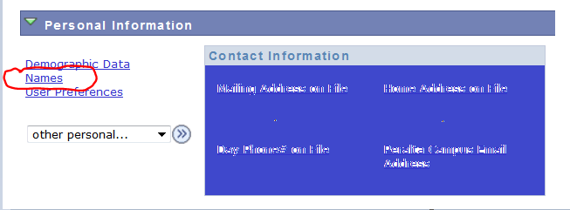

- Click the ‘Add A New Name’ button
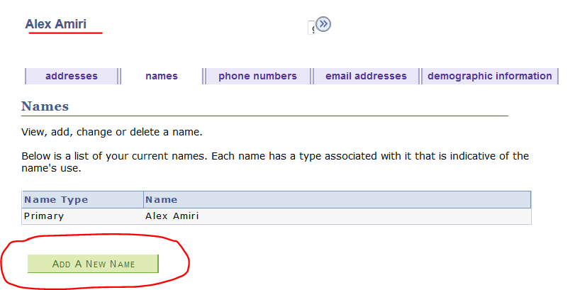

- Enter your new Preferred First Name information and click the Save button.

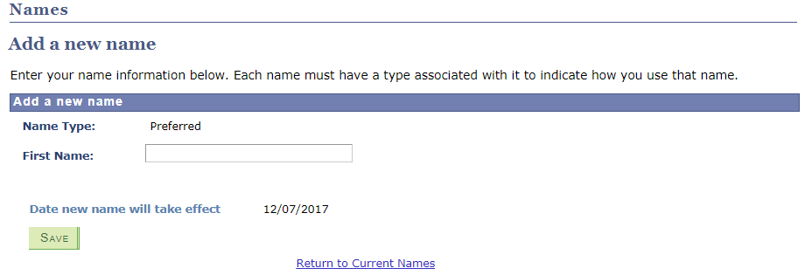

- Click Ok on the Save Confirmation page
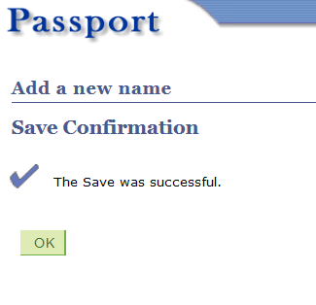

- In order to view your new Preferred Name, you will need to log out and log back in to your Student Center. The new name will show in the fields highlighted below.

Keep in mind that you will be allowed to change/update your Preferred Name multiple times on the same day, but those changes will be locked in at the end of the day and you will no longer be able to make any changes for one year.

For example, if you add a Preferred Name on 6/5/2017, you will be allowed to make several changes on this day. At the end of the day the Preferred Name will be locked in and you won’t be allowed to update your Preferred Name until 6/5/2018.

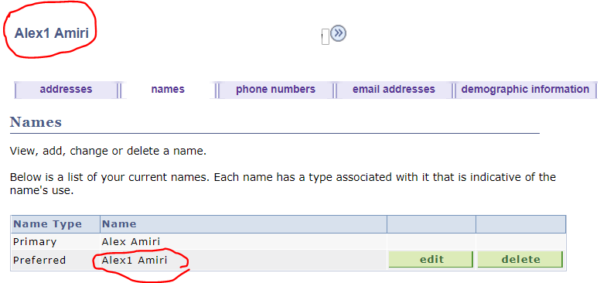

- If you attempt to update your Preferred Name in less than a year, an error message will display the date of your most recent update and it will prevent you from making any changes
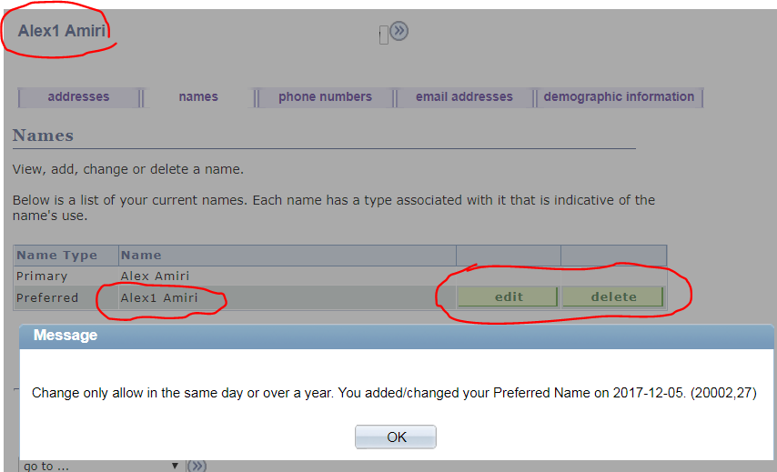

- This screenshots below shows you the different pages that will display your Preferred Name:

Student Center – Personal Information
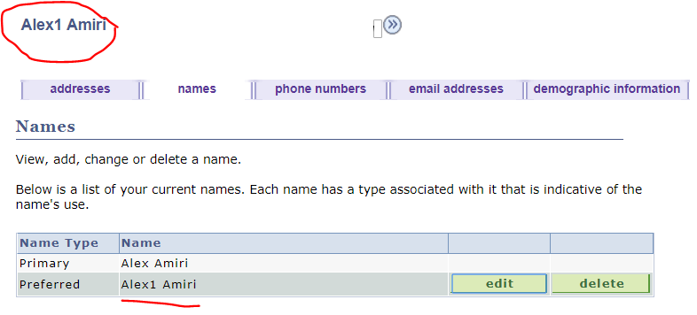

Student Center – Class Schedule
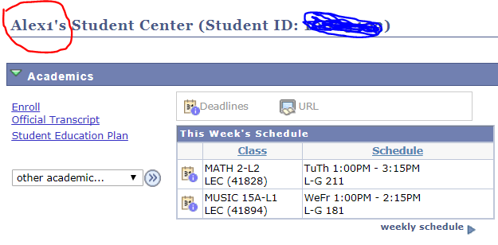

Instructor’s Class Rosters
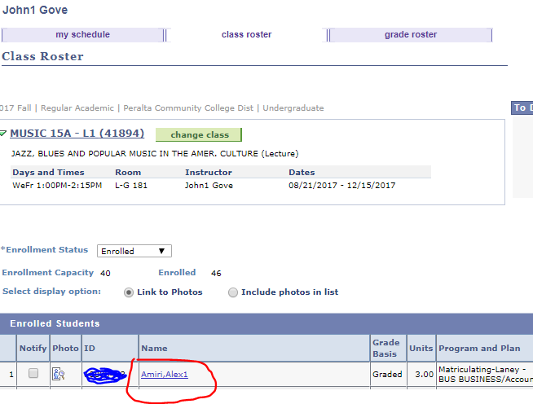

Instructor’s Printable Class Rosters

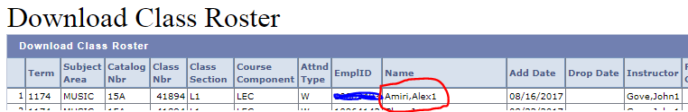

Instructor’s Grade Rosters

