Latinx and LGBTQ: Conversations with Community Leaders
October 7, 2019 at 6:00p.m., F-Building Lounge, College of Alameda

Please join us for an evening with Latinx LGBTQIA leaders hosting community conversations representing the voices of people of color within the queer community.

Presenters for the evening:
Moderator:

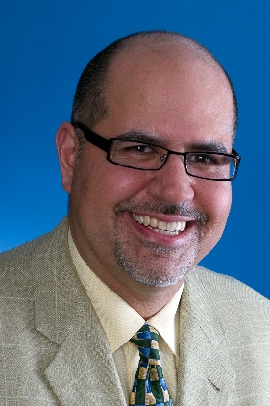
Dr. Francisco Buchting
As the Vice President of Grants, Programs, and Strategic Initiative, Francisco oversees all of the foundation’s grantmaking, leadership, and community programs. Francisco brings to Horizons a background as a research scientist, a public health professional, and an experienced grantmaker. His 25 years of experience in government, academia, nonprofit organization, and community activism have blended scientific expertise, commonsense public health experience, research, organizational re-engineering, and grantmaking. He has also served on numerous community-based organization boards and museum advisories. In recent years, Francisco has played a national leadership role in understanding and reducing health disparities and inequities in the LGBT and Latino communities, and has been active in advancing knowledge brokerage initiatives, and “big data” research. His career includes bilingual clinical practice in behavioral medicine with a special focus on chronic diseases. He has co-authored a bimonthly newspaper column on health, written numerous research articles, and produced research reports. Francisco, holds a Ph.D. and M.A. in clinical psychology from Boston University, along with bachelor’s degrees in philosophy and psychology from the University of California, Davis.

Panelists:
Dr. Rosio Alvarez – Chief Information Officer, Lawrence Berkeley National Laboratory
Bio forthcoming.

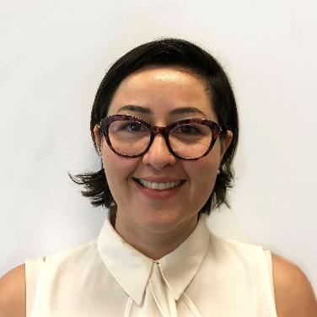
Melissa Diaz-Infante is the Development and Communications Associate at Oasis Legal Services, a Berkeley-based nonprofit protecting LGBTQIA+ immigrant lives through asylum. Melissa is a graduate of Boston College, where she attended as a Gates Millennium Scholar. Originally from Salinas, CA, Melissa has been in the Bay Area for over 12 years. She has coordinated arts- and performance-related advertising at The San Francisco Chronicle and multi-faceted community arts projects for Intersection for the Arts, mentored young adults with Autism, worked on productions at Bindlestiff Studio in a variety of capacities, and has been a regular volunteer at Creative Growth Art Center for over two years.

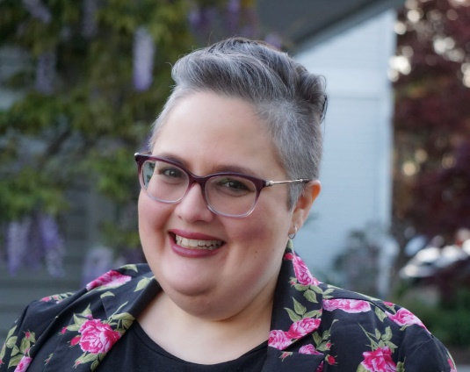
Maritza Martinez is the Executive Director of Somos Familia, where she works with a grassroots team of volunteers and staff to support families with children who identify as lesbian, gay, bisexual, transgender or queer (LGBTQ) and conduct community education to create spaces that welcome and celebrate LGBTQ Latinxs and their families. As a queer Latina, a nonprofit professional, leader, and an activist, her work with Somos Familia is deeply personal and she strongly believes that change comes from family leadership within the community she serves. Maritza is a founding member of the LGBTQ Latinx Giving Circle at the Latino Community Foundation. In 2019, she was selected as a Rise Up Leader in their first California cohort of the Gender Equity Institute. Prior to joining Somos Familia, Maritza worked as an organizational development consultant working with organizations from across the country in fields including diversity, leadership, environment, education, and innovation. She served as a program manager at both Green for All and New York Needs You (now America Needs You). She earned a Bachelor’s degree in Political Science from The University of the District of Columbia and a Master’s degree in Nonprofit Management from The Milano School of Policy, Management, and Environment at the New School. She is a recovered New Yorker living in Oakland, CA.

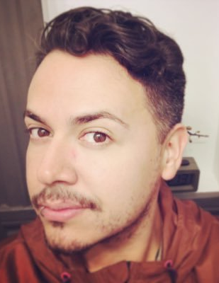
Anthony Morin serves as Protocol Officer under Mayor London N. Breed; he builds bridges between the City and County of San Francisco and the International community. Anthony serves the San Francisco Consular Corps and works in managing these key partnerships, all while bringing different cultures together. Anthony holds a Bachelor’s degree in French from San Francisco State University and an International Relations certificate from the Institut Catholique de Paris. Anthony is a seasoned professional in operations and strategic partnerships. Prior to his current post with the Mayor’s Office, Anthony was the Corporate Relations and Events Manager at Horizons Foundation (an LGBTQ community foundation), where he lead in developing, and executing large-scale events, while sustaining, growing and managing key relationships to help fundraise for the LGBTQ community.

As a French-speaking-Latino, his life is and will always be committed to champion inclusion, diversity and cultural partnerships. Anthony’s professional experiences have taken him around the world, where he was able to develop cross-cultural exchanges and forge deep relationships across many walks-of-life, while teaching English to underserved youth in the suburbs of Paris from 2008 until 2010. Since then Anthony has excelled in building many partnerships across an array of community leaders, corporations and nonprofit organizations.

In his spare time, Anthony dedicates himself to help lead a group of young Latino professionals through the LGBTQ Latinx Giving Circle, with the Latino Community Foundation, that helps create change in his community through grants made by his Giving Circle to nonprofits around the Bay Area that support the Queer Latino community with immigration services, mental health resources, youth leadership development and the arts.

