AMATYC Contest (Fall 2010) SOLUTIONS

- [D] The perimeter of each rectangle is three times the length of a side of the square.
- [C] The cost of milk to that of bread was 150:100 last year, and so (150)(120%):(100)(125%) this year, i.e. 180:125, or 36:25, i.e. 144:100.
- [C] 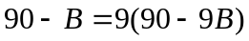. Solve it to get 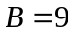.
- [B] The product of all roots of 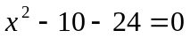 is the constant term 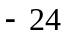.
- [E] The probability that the product is odd is 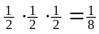. So the answer is 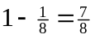.
- [A] 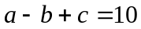, 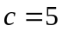, 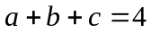. The 3rd equation minus the 1st equation gives 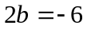, so 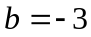. The 3rd equation gives 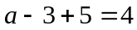, so 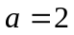. So 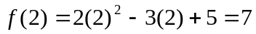.
- [A] The line segment joining 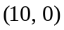 and 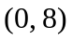is of slope 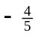, giving a lattice point along that line segment for every horizontal distance of 5, i.e. 3 lattice points as a whole. There are 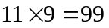 lattice points on or inside the rectangle formed by 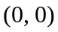, , 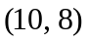 and . Of them 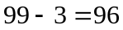 are off the diagonal joining and , i.e. 48 on either side.. The answer is 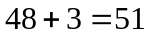.
- [B] 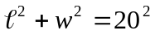, 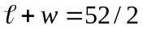. But 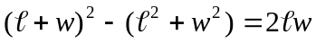, so 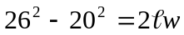. Thus 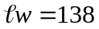.
- [A] The number of 1-digit even numbers = 4. The number of 2-digit even numbers = (the number of 1-digit numbers)5=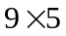. The number of 3-digit even numbers = (the number of 2-digit numbers) 5=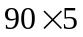. The even numbers so far contribute digits. The remaining 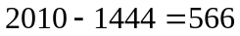 digits come from 4-digit even numbers. 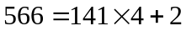, so the answer is the hundreds digit of the 142nd four-digit even number, 1282.
- [A] A number is divisible by 7 precisely if, when the digits, starting from the ones digit, are multiplied by 1, 3, 2, 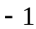, 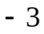, 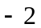, 1, 3, 2, …, respectively, the sum of the products is divisible by 7. Since AMATYC is divisible by 7, is divisible by 7. Let A be 1, M be 0. In order for AMATYC to be divisible by 5, C has to be 5 (as 0 is taken by M.) So 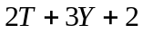 is divisible by 7. If 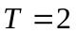, then 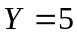, which is taken by C already, so it won’t work. If 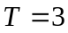, then 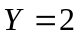. So 101325 is the smallest one possible.
- [B] Want a number such that 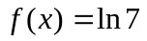. I.e. 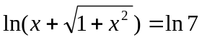, so 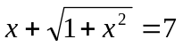, so 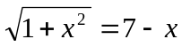, 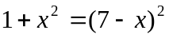, so 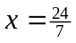.
- [A] Let 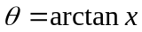, then 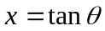. But 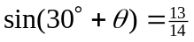, so 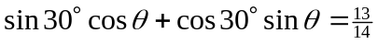, i.e. 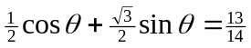. Divide through by 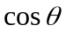 to get 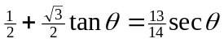, i.e. 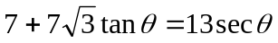. Square both sides to get , so 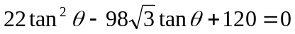. The quadratic formula gives 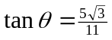.
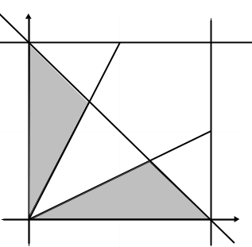
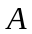
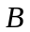
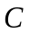
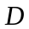
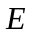
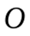
- [D] 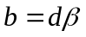, 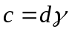. So 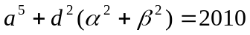, 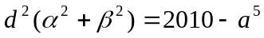. 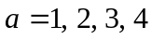. For each of them, calculate 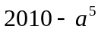 and factor it completely to see if it has a double prime root. Only 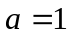 has such a property, with 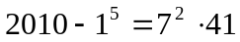. So 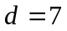 (with 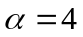, 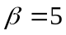.)

- [C] The problem boils down to calculating the percentage of the 1 x 1 square shown that is shaded. Note that 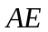 is half of 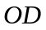, so 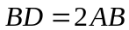. But 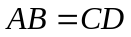. It follows that 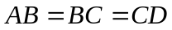, so the shaded area is of the square.
- [D] As shown in the accompanying picture, the area is .

- [E] For  to make sense, has to satisfy 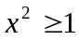. So, for 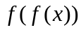 to make sense, we see 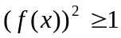, i.e. 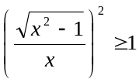, and so 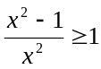, which is impossible.
- [B] The integer geometric sequence is , , 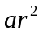, …. The integer arithmetic sequence is , 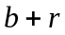, 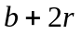, ….. So 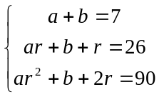. The 2nd minus the 1st gives 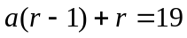, and the 3rd minus the 2nd gives 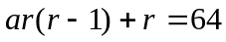. Multiple by on both sides to get 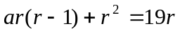. Comparing this with , we see that 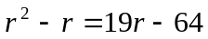. Solve this quadratic equation to get 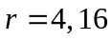. Rule out 16, as which would read 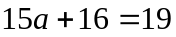, would not give an integer for .
- [E] 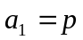, 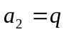, 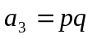, 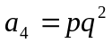, 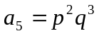, 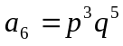, 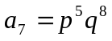. So 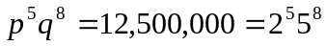, 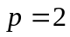, 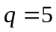. 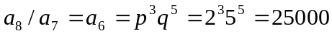.
- [E] , where all coefficients are nonnegative integers. It follows from the condition 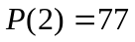 that 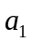, 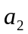, etc are all strictly less than 77. It also tells us that 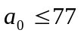. But if 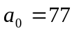, then 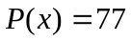, contradicting 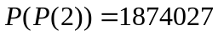. So 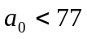 too. Now reads , making 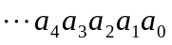 a base-77 representation of 1874027. So repeatedly divide 1874027 by 77, the resulting remainders give this representation . This gives . So 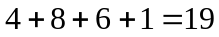 is the answer.
- [B] Note that 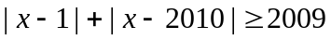, , …, . It follows that . The equality holds when, for example, is 1005.5.

