Chapter 6

List the common types of EM radiation and their approximate wavelengths. Relate these radiations to everyday uses and changes in matter.

You should realize that the boundaries between the areas of the spectrum are not sharp divisions but rather gradual transitions. It is helpful to associate the various types of radiation with the changes in matter they produce or that produce them. These associations are mutual. For example, infrared radiation may cause changes in vibrations of molecules when it strikes them or a change in how a molecule vibrates may produce infrared radiation. In fact, this is how spectroscopy is used to identify molecules. Specific parts of molecules absorb light or specific wavelengths. By detecting this absorption, we can identify a particular molecule.

Table 1:Changes in associated with various types of electromagnetic radiation

types of radiation | approximate length | associated change in matter | Effect of the energy
cosmic rays g rays (ionizing) | 0.1 pm | nuclear transformations changes in nuclear structure | Broken bonds, DNA damage | Broken bonds, DNA damage
x rays (ionizing) | 0.1 nm | inner electronic transitions in atoms | Broken bonds, DNA damage | Broken bonds, DNA damage
ultraviolet rays (ionizing) | 100 nm | outer electron transitions in atoms and in molecules (causes many of the colors we see) | Broken bonds, DNA damage, Optical, electronic excitation
visible | 0.5 µm | outer electron transitions in atoms and in molecules (causes many of the colors we see) | Optical, electronic excitation
infrared radiation | 10 µm | vibrations of atoms in molecules | Optical, electronic excitation, thermal
microwave radiation | 1 cm | rotation of molecules | Thermal, high induced currents, heating
radar | 1 m | rotation of molecules | Thermal, high induced currents, heating
radio | 10 m | modifications of nuclear spins (NMR and MRI) | Thermal, high induced currents, heating
television | 1 km | translation of molecules (their movement) | Thermal, high induced currents, heating

Explain how light is dispersed into a spectrum and the differences between a continuous and a line spectra.
When light passes through a prism, it is refracted or bent as it enters and as it leaves the prism. Different frequencies of light are refracted to different degrees. High frequency light is refracted the most and low frequency light is refracted the least. Thus, among the colors of visible light, red light is refracted least, next orange, then yellow, green , blue , and indigo and finally, violet, which is refracted the most. You can remember which is bent the most by imaging that high frequency light interacts the most frequently with the matter of the prism as it passes through and thus is refracted most. This is only a memory aid, not what actually occurs; the process is a little more complex and involves energy transfers not discussed in this class. Refraction occurs at the surface of the prism. When a prism disperses white light, it produces a continuous spectrum. When an element is heated in a flame, and a prism disperses the resulting light, the spectrum consists of several lines. The pattern of lines is characteristic of the element being heated giving off light.

Be able to apply Bohr model of the hydrogen atom, the assumptions, the picture of the atom, the energy expression, and the energy level diagram
The Rydberg equation describes the different lines of each series study in the hydrogen spectrum. They are Lyman (UV) (n= 1), Balmer (vis) (n= 2), Paschen (n=3), Brackett, Fpund and Humphries (all IR). These are all whole number transitions that occur in the hydrogen atom. The Rydberg equation is a summary of experimental data and not based on a theoretical model.
To explain the Rydberg equation, Bohr proposed a model of the hydrogen atom based on several assumptions.
- The electron moves around the nucleus in one of several circular orbits. The electron does not spiral into the nucleus as classical physics requires
- In each orbit of radius r, the angular momentum of the electron (m_{e}vr, [mass, velocity, radius]) is restricted to values of (nh/2π), where n is a whole number. This means the electron is quantized.
- When an electron moves from one orbit to another, the energy difference, ∆E, between the two orbits appears as light emitted (if the second orbit is lower than the first and absorbed if the second orbital is higher than the first.
After some algebraic manipulation , these equations along with the principles of classical physics, give expressions for the energy of each orbit and the difference in energy between two orbits.

- E = -2.179 X  10⁻¹⁸J/n².
- ∆E = -2.179 X  10⁻¹⁸J(1/n²_{f} —1/ n²_{i})
- 1/λ =-2.179 X  10⁻¹⁸J(1/n²_{f} —1/ n²_{i})or  (frequency) = c/λ = -2.179 X  10⁻¹⁸J(1/n²_{f} —1/ n²_{i})or
E = hc/λ = -2.179 X  10⁻¹⁸J(1/n²_{f} —1/ n²_{i})
The wavelength of light observed is given by the Rydberg equation which is now based on a theoretical model When the energies determined from [1] are plotted an energy diagram is produced. this diagram illustrates the various possible values of ∆E. Another aspect of each series in the hydrogen spectrum is the series limit. The energy levels get closer to each other as the quantum number n increase. Thus, the spectral lines are also closer.

Summarize de Broglie’s and Heisenberg’s contributions to the modern view of the atom.
A serious problem with Bohr’s model is his assumption that the electron does not decay and lose energy as it moves in a circular path about the nucleus. Louis de Broglie rationalized (and his theory was verified by Davison and Germer) that a particle of mass, m, and velocity, v, has a wavelength given by λ = h/mv. An integral number of wavelengths must fit in a circular orbit of the atom. de Broglie does much more than support Bohr’s theory, it s a fundamental fact of nature. Particles moving at high velocities have wave properties; but even this statement is not complete. Particles are waves. It merely depends on how we observe them. In the same way a woman can be both a mother to her children and a surgeon, depending on how or when we observe her.
Another consequence of this wave particle duality is the Heisenberg uncertainty principle. This uncertainty is a fundamental limitation of nature, not a result of the crudeness of measuring devices. This leads to a different picture of the electron in the atom. Bohr’s definite orbits are replaced by orbitals. Orbitals are regions of space in which there is a reasonable chance for finding an electron with a 90% probability. We can picture the orbital as a boundary for the electron thinking about the boundaries of a city. If we want to find a citizen of the city, we have a 90% probability of finding that citizen if we look in the boundaries of the city. The same is true for an electron. We believe there is a good chance or a high probability of finding the electron within the boundaries of the orbital.

Explain the differences between Bohr and Schrödinger’s models of the atom
Bohr treated the electron as a classical particle fixed in certain orbits defined by its wavelength. Schrödinger allows the electron to fully express its wave properties. Schrödinger’s electron does not plod around an orbit but totally fills the space of the orbital. If does not fill this space as it would a fly in a cage but rather as a gas fills a bottle. Yet it does not fill the space by breaking into fragments or by making itself larger, but rather in a way that a sound wave fills the room. Unfortunately the mathematics describing the Schrödinger atom are more complex than those need by the Bohr model, but the results cab be summarized in rules and visualized by the quantum numbers and the shapes of the orbitals.

Know and be able to apply the quantum number relationships of wave mechanics
The principal quantum number is designated by n and is a whole number larger than zero. Electrons with the same n are in the same energy level or shell. Thus all electrons n =1 are in the first shell. The average distance of the electron from the nucleus almost entirely depends on n.
The azimuthal quantum number l (the orbital quantum number) is a non-negative whole number less than n. l can equal 0, 1, 2, 3, n -1. Electrons with same value of l are in the same sub-shell or sublevel. Sub-shells are designated by lower case letters
value of l | 0 | 1 | 2 | 3 | 4 | 5 | 6 | 7
sub-shell | s | p | d | f | g | h | i | k
The energy of a many electron atom depend on the sum n + l. Also, l specifies the shape of an orbital. The magnetic quantum number ml is also called the orientation quantum number. It specifies the general direction of the orbital, the direction in which it points.

Learn the three basic principles governing electron configuration
- The order in which orbitals are filled. The order follows the periodic table.
- The Pauli exclusion principle and its implications: The Pauli exclusion principle states that no two electrons in an atom may have the same set of four quantum numbers . An orbital contains electrons that have the same n, l, and ml hence the ms or spin quantum number must be different for the two electrons in an n orbital. Note the ms is ± ½. The number of orbitals in a sub-shell is governed by ml that ranges from –l→+l by whole number steps. The number of electrons in a sub-shell is twice the number of orbitals. Therefore, orbitals are “odd” and electrons are “even” for total numbers in a sub-shell. Also, the number of sub-shells in a principal quantum number is the quantum number. For example n = 3 has 3 sub-shells, 3s, 3p, and 3d. They may not be consecutively filled.
- Hund’s rule of multiplicities: The multiplicity of an atom related it its total spin or the sum of the spin quantum number ms. Huns rule states that when electrons fill orbitals of the same energy, they do so with the same values of ms, if possible. We can represent orbitals as boxes and the electrons as arrows. An up ↑arrow would be ms = ½ and a down ↓arrow would be ms = -½.

I dentify, and distinguish between the different types of orbitals and sketch them
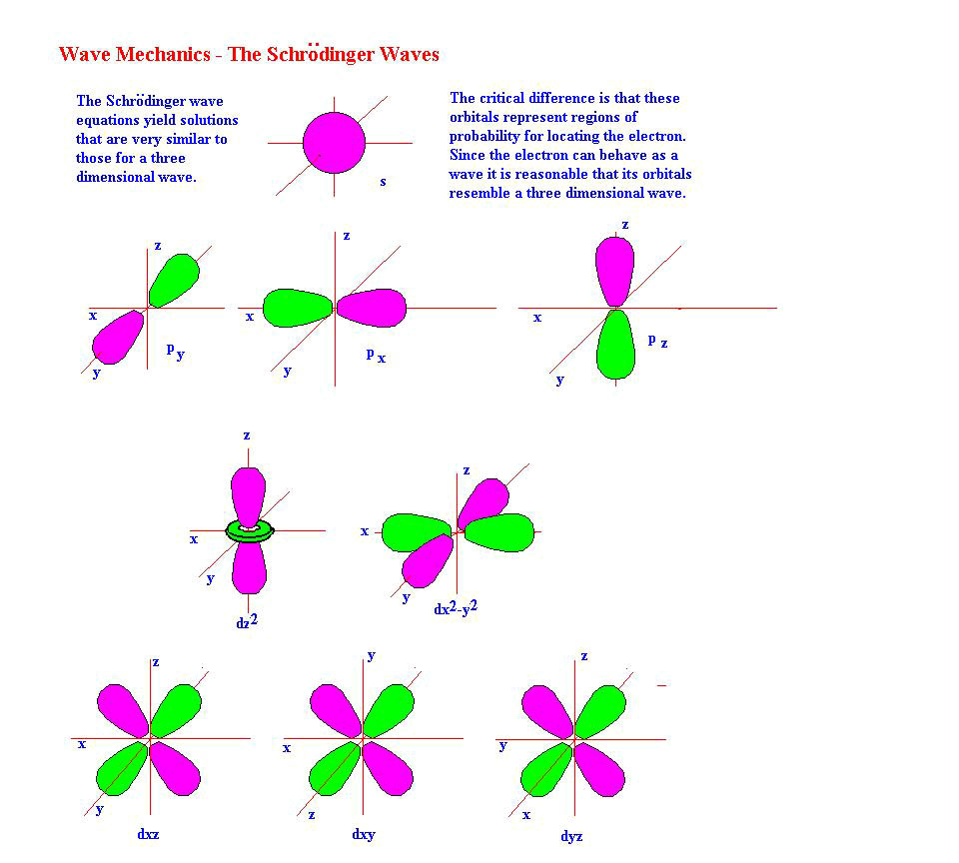

Know how orbital energies are modified when more than one electron is present in an atom
For one electron atoms and ions, such as H and He+, orbital energies depend on only the principal quantum number n, As other electrons are added, the principal levels split into sub levels of different energies. Sometimes when atoms combine, the orbitals within a sub shell also have different energies. The general order is 1s2s2p3s3p4s3d4p5s4d5p6s4f5d6p7s
Remember that each orbital can hold two elections. thus an s sub-shell with one orbital can hold two electrons a p sub-shell can with three orbitals can hold six electrons and a d orbital with 5 sub shells can hold 10 electrons. The row of the periodic table is the principal quantum number.

1s
2s |  |  |  |  |  |  |  |  |  |  |  | 2p
3s |  |  |  |  |  |  |  |  |  |  |  | 3p
4s |  | 3d |  |  |  |  |  |  |  |  |  | 4p
5s |  | 4d |  |  |  |  |  |  |  |  |  | 5p

4f
5f

Apply Aufbau principle
With the Aufbau process, one builds the electron configuration of an atom upon the configuration of the previous atom, that of the next lowest atomic number. There are many ways to write electron configurations. One is to give the four quantum numbers of the last electron added. This method does not show changes of 1 electron in for example the d sub-shell. When you assign the sign for ms you must be consistent. For example , H and He have the same QN but vary by a + sign. B, C, and N have the same m_{s} sign, but O, which starts a refill of the 2p orbitals must have a –m_{s}.
QN | H | He | Li | Be | B | C | N | O
n | 1 | 1 | 2 | 2 | 2 | 2 | 2 | 2
l | 0 | 0 | 0 | 0 | 1 | 1 | 1 | 1
ml | 0 | 0 | 0 | 0 | –1 | 0 | 1 | –1
m_{s} | ½ | -½ | ½ | -½ | ½ | ½ | ½ | -½

Electron configuration is written more compactly as an energy level diagram so called because the vertical direction indicates the approximate orbital energy. The electrons are put in boxes that represent an orbital to be filled by two electrons drawn as arrows. When the energy level diagrams are written in one line, they are called orbital diagrams.
Of course we must remember Hund’s rule. A useful generalization is that half filled sub-shells are unusually stable and that if they can be obtained by “moving” only one electron between very closely spaced energy sub-shells, one should do so. The closely spaced sub-shells are [4s and 3d], [5s and 4d], [6s, 4f, and 5d] in the order in the bracket. This works fine for elements with atomic numbers less than 60 but not very well after that.
A more compact notation is spdf or spectroscopic notations. The spdf originally described emission spectra lines as sharp principal, diffuse and fundamental. One writes the sub-shells in order of increasing energy and indicates the number of electrons in each sub-shell with a superscript. Sometimes the orbitals are written in the order of increasing n value. If we which to show how the electrons are paired in unfilled sub-shells we written the individual orbitals and the number of electrons in them.

4 p $\boxed{} \boxed{} \boxed{}$
3d $\boxed{} \boxed{} \boxed{} \boxed{} \boxed{}$
4s $\boxed{}$
3p $\boxed{} \boxed{} \boxed{}$
3s $\boxed{}$
2p $\boxed{} \boxed{} \boxed{}$ 2p ↑ ↑
2s $\boxed{}$ 2s ↑↓
1s $\boxed{}$ 1s ↑↓

Box diagram for Carbon: 1s ↑↓ 2s ↑↓2p ↑ ↑ Can also be in a box!
spdf (spectral) notation for carbon: 1s² 2s² 2p²
spdf (spectral) notation for Se: by order of the periodic tabled 1s²2s²2p⁶3s²3p⁶4s²3d¹⁰4p⁴ (ordered by energy): 1s²2s²2p⁶3s²3p⁶3d¹⁰4s²4p⁴ (noble gas configuration); [Ar] 4s²3d¹⁰4p⁴

Wismer, Robert K.; General Chemistry, Student Study Guide, 6th edition
http://intranet.micds.org/upper/science/text/chemistry_textbook/ch03/images/orbitals.jpg

