**Math 203 Practice Test 1**

No notes, books, cell phones, tablets, translators, mp3 players, or earphones are allowed on the test. I will not answer any questions during the test. Bring a calculator to the test.

1. Determine whether each of the following is the graph of a function. (Sec 7.1)

a.

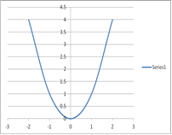

b.

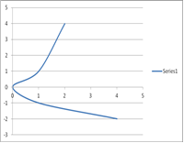

c.

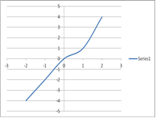

2. Given the correspondence (Sec 7.1)

a. Write the domain.

b. Write the range.

c. Determine whether the correspondence is a function.

3. Find the indicated function values for the function.(Sec7.2)

a. b. c.

4. Find the domain of the function. (Sec 7.2)

a.  b. 

5. In 1994, the life expectancy of females in the U.S. was 79.0 years. In 2004, it was 80.4 years. Let E(t) represent life expectancy and t the number of years since 1990. (Sec 7.3)

a. Find a linear function that fits the data.

b. Use the function of part (a) to predict the life expectancy of females in 2012.

6. Graph (Sec 7.3)

a. b.

7. Let and Find each of the following. (Sec 7.4)

a. b.

8. The cost of a dinner varies directly as the number of people fed. In 2011, a request for donations for a Thanksgiving dinner read, “You can feed seven people with a gift of $15.75.” How many people could be fed with a gift of $27.00? (Sec 7.5)

9. The frequency of a string is inversely proportional to its length. A violin string that is 33 cm long vibrates with a frequency of 260 Hz. What is the frequency when the string is shortened to 30 cm? (Sec 7.5)

10. Solve using either the substitution or elimination method. (Sec 8.2)

a.  b.

11. Stacey’s two student loans totaled $12,000. One of her loans was at 6.5% simple interest and the other at 7.2%. After one year, Stacey owed 811.50 in interest. What was the amount of each loan? (Sec 8.3)