**Math 3A Test 1** Name_______________________________________________ Show All Work

1.Solvefor all in.

2. The pointlies on the curve. If Q is the point, find the slope of the secant line PQ for .

3. For the function f whose graph is given, state the value of each quantity, if it exists. If it does not exist, explain why.

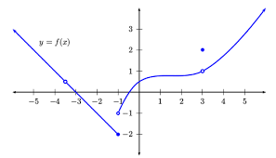

a. b. 

c.  d.

e.  f. 

4. Evaluate the limit, if it exists.

a.  b. 

5. Is there a number a such that  exists? If so, find the value of a.

6. Use the Intermediate Value Theorem to show that there is a root of the equation in the interval (2, 3) given the function is continuous on [2, 3]. You must show work to earn credit.

7. Find the horizontal and vertical asymptotes of the curve .

Horizontal Asymptote:________________

Vertical Asymptote:__________________

8. Write both definitions of the derivative.

a. b.

9. Find using the DEFINITION of the derivative (either one of the two) given You must show work to earn credit.

10a. Use the DEFINITION of the derivative to find the slope of the tangent line to the curve  at the point (25, 5). You must show work to earn credit.

10b. Find an equation of the tangent line in part (a).