**Calculus 3A Test 2** Name__________________________________

1. Given the graph ofbelow, sketch the graph of

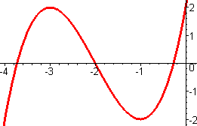

2. Differentiate the functions, given a, b, c and d are constants. There is no need to simplify!

a.

b. 

c.

d.

3. Find an equation of the tangent line to the curveat the point.

4. Suppose that. Find the following values.

a. b.

5. If

6. Use logarithmic differentiation to find the derivative of 

7. The height (in meters) of a projectile shot vertically upward from a point 6 m above ground level with an initial velocity of 28 m/s isafter t seconds.

a. Find the velocity after 3 seconds.

b. When does the projectile hit the ground?

c. With what velocity does it hit the ground?

8. A bacteria culture initially contains 200 cells and grows at a rate proportional to its size. After an hour the population increased to 580.

a. Find an expression for the number of bacteria after t hours.

b. Find the number of bacteria after 5 hours.

c. Find the rate of growth after 5 hours.

d. When will the population reach 80,000?

5% Bonus: Prove either the Power Rule, the Product Rule, or 