**Math 3A Test 4**  Name______________________________________________________

On this test no notes, books, cell phones, mp3 players, tablets, translators, earphones, or any electronics (except calculators) are allowed. I will not answer any questions during the test!

SHOW ALL WORK

1. A baseball team plays in a stadium that holds 30,000 spectators. With ticket prices at $24, the average attendance had been 14,000. When ticket prices were lowered to $20, the average attendance rose to 21,000.

a. Find the demand function, assuming that it is linear.

b. How should ticket prices be set to maximize revenue?

2. Use Newton’s method with to find  (to three decimal places) given the equation.

3. Find f given

4. A stone was dropped off a cliff and hit the ground with a speed of 200 ft/s. What is the height of the cliff? (Use acceleration)

5. Estimate the area under the graph offromtousing four rectangles and left endpoints.

6. Use the form of the DEFINITION of the integral to evaluate. You must show work to earn credit.

7. The graph of f is shown below. Evaluate each integral by interpreting it in terms of areas. 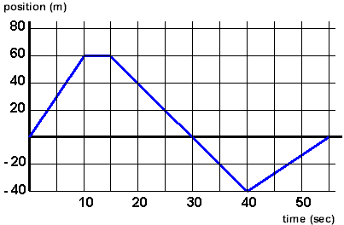

a. b.

8. Evaluate the definite integrals.

a. b.

9. Use Part 1 of the Fundamental Theorem of Calculus to find the derivative of